**BUSINESS CONNECT**

**BY**

**ASRAF ANSARI**

**T.U. Roll No. : 9297/18**

**T.U. Registration No. : 7-2-479-38-2018**

Hetauda School of Management and Social Sciences

*A Summer Project Report Submitted to*

**Faculty of Management, Tribhuvan University**

in partial fulfillment of the requirements for the degree of

**Bachelor of Information Management**

Hetauda

August/2022

# **STUDENT DECLARATION**

This is to certify that I have completed the Summer Project entitled “**Business Connect**” which is a web-based e-commerce platform, done under the guidance of **Mr. Dikshant Ghimire** in partial fulfillment of the requirement for the degree of **Bachelor of Information Management** at Faculty of Management Tribhuvan University. This is my original work and I have not submitted it earlier elsewhere.

Date: 6th August, 2022

Signature:

Name: Asraf Ansari

# **CERTIFICATE FROM THE SUPERVISOR**

This is to certify that the summer project entitled “**Business Connect**” is an academic work done by **Mr.Asraf Ansari** submitted in partial fulfillment of the requirements for the degree of Bachelor of Information Management at Faculty of Management, Tribhuvan University under my guidance and supervision. To the best of my knowledge, the information presented by him in the summer project report has not been submitted earlier.

Signature of the Supervisor

Name: Er. Dikshant Ghimire

Designation: Asst. Professor

Date:

# **LETTER OF APPROVAL**

This is to certify that we have read and recommended to the Faculty of Management for acceptance of a summer report entitled “**Business Connect**” submitted by **Mr.Asraf Ansari** in partial fulfillment of the requirement for BIM, sixth semester awarded by Tribhuvan University.



Mr. Sameer Gautam External Examiner

Head of IT Department

Hetauda School of Management

and Social Sciences

Hetauda, Nepal

# **ACKNOWLEDGEMENTS**

This project has been an excellent opportunity for me to explore my knowledge and skill. The success and outcome of this project required a lot of guidance and assistance from many people, and I am highly privileged to get the support to complete my project. All that I have done is only due to such supervision and assistance, and I would not forget to thank them. I want to extend my sincere thanks to all of them.

Special thanks to the University for including such a task in the curriculum of BIM. Thanks to our college, Hetauda School of Management and Social Sciences for providing the environment and supporting all the stages of this project. I would like to thank our Head of IT Department, **Mr. Sameer Gautam**, and my project supervisor, **Mr. Dikshant Ghimire**, for valuable guidelines, supervision, and suggestions to complete this project successfully.

My thanks and appreciation to all the people's direct and indirect help remained valuable and crucial at different project stages. This outcome is the result of their support and encouragement.

Name: Asraf Ansari

Exam Roll No: 9297/18

# **EXECUTIVE SUMMARY**

This report documents the whole components of the website Business Connect. Nepal is growing in terms of IT and business and research shows the many small business owners in Nepal relied on telecommunication for business which is expensive & not efficient.

Business Connect is built to enable small business owners and vendors to have hassle free communication while conducting business. This is done via an online platform similar to now popular online shopping sites like daraz. The users can simply create and account and start business.

# **Table of Contents**

*Title page of the Summer Project Report*

*Student Declaration i*

*Certificate from the Supervisor ii*

*Letter of Approval iii*

*Acknowledgements iv*

*Executive Summary v*

*Table of Contents vi*

*List of Figures viii*

*List of Tables ix*

*Abbreviations x*

Chapter I: Introduction 1

1.1 Background 1

1.2 Objective 1

1.3 Methodology 1

1.3.1 Data & Information 1

1.3.2 Project Framework 1

1.3.3 Tools Used 3

Chapter II: Task and activities performed 4

2.1 Analysis of tasks, activities, problems, issues 4

2.1.1 Analysis of tasks 4

2.1.2 ER-diagram 5

2.2 Analysis of Possible Solution 6

2.2.1 Requirement Analysis 6

2.2.1.1 Functional Requirement 6

2.2.1.2 Non-Functional Requirement 6

2.2.2 Software and System Architecture 8

2.2.2.1 Architecture Objective 8

2.2.2.2 Three-Tier Architecture 8

2.2.3 Class Diagram 10

2.2.4 Activity Diagram 11

2.5 Sequence Diagram 12

2.6 Use Case Diagram 13

2.7 Test Cases 13

Chapter III: Discussions & Conclusions 15

3.1 Discussions 15

3.2 Conclusions 15

References 16

Appendix 17

# **List of Figures**

Figure 1: Agile methodology 1

Figure 2: Entity Relationship Diagram 5

Figure 3: Three-tier architecture 9

Figure 4: Class diagram 10

Figure 5: Activity diagram 11

Figure 6: Sequence diagram 12

Figure 7: Use Case Diagram 13

Figure 8: Test cases 14

Figure 9: Index page 17

Figure 10: Retailer login portal 17

Figure 11: Retailer registration page 18

Figure 12: Registration form validation 18

Figure 13: Registration Mail Verification 19

Figure 14: Edit User Account 19

Figure 15: Cart 20

Figure 16: Add product by wholesaler 20

Figure 17: View own products added by wholesaler 21

Figure 18: Order made by customer 21

Figure 19: Admin dashboard 22

Figure 20: Admin insert user 22

Figure 21: Database overview 23

# 

# 

# 

# 

# 

# 

# 

# **List of Tables**

Table 1: Tools used 3

Table 2: Cost estimate for website additional functionality in 2022 7

# **ABBREVIATIONS**

Admin: Administration

BIM: Bachelor of Information Management

ER: Entity-Relationship

SQL: Structured Query Language

TU: Tribhuvan University

UC: Use Case

# 

# **CHAPTER I: INTRODUCTION**

## **Background**

Business connect is a website which aims to resolve the delay & hassle of communication faced by wholesalers and retailers in Nepal. Nepal is growing both in terms of IT & business. One of the major flaws between these two, is communication & transaction This is where Business connects aims to be established, between wholesaler & retailers & provide them with solutions. The online website will widen the market for wholesalers to sell their goods in different parts of the country.  Retailers will be able to see different lists of products, make the orders, and buy the products. The final milestone of this project is to be well established inside the country & expand outside the country while helping all kinds of business owners.

## **Objective**

* The main objective of the project is to provide online website to connect wholesalers with the retailers.
* To widen the market for wholesalers to sell their goods in different parts of the country.
* To provide a platform for small wholesalers for selling their goods instantly.
* To provide and easy to use website.

## **Methodology**

### **Data & Information**

Observation method was used to find weaknesses in sectors of IT. A spot was found & well studied. The primary methods of data collection were used, which were used as research notes for the project.

### **Project Framework**

#### **Agile**

An efficient framework used in this project which enables a project to be broken into phases and make changes where possible even at later phases; this method is applied in this project.

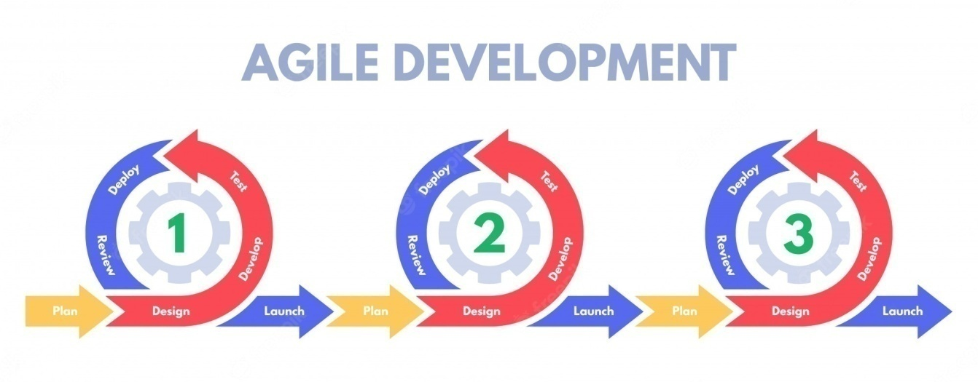

Figure 1: Agile methodology

**Justification:**

* Superior quality product
* Customer satisfaction
* Better control
* Improved project predictability
* Reduced risks
* Increased flexibility
* Continuous improvement
* Improved team morale
* More relevant metrics

**Sprint**

As this project is based on the agile methodology, the entire project is divided into smaller parts to develop the project in the time frame which will allow the project to finish in time and help to keep the track of the project. Dividing the project into sprints will allow the governing body to monitor the project development and identify the possible risk factors and mistakes as well.

**Justification:**

* More focus
* Reduced costs
* More transparency
* Improved morale
* Better quality
* Higher productivity
* Higher customer satisfaction
* Adaptability
* Team building
* Reduced risks
* The Sprint cycles

### **Tools Used**

Table 1: Tools used

|  |  |  |
| --- | --- | --- |
| **S.N.** | **Software Tools** | **Purpose** |
| 1. | Ms-word | Documentation |
| 2. | MS team | Communication |
| 3. | GitHub | Code management and Updates |
| 4. | Draw.io | UML Diagrams |
| 5. | PowerPoint | Presentation tools |
| 6. | Ms-Excel | Charts |
| 7. | IDE | Visual Studio Code |
| 8. | Language | HTML, CSS, Bootstrap 4 (Frontend) & PHP (Backend) |
| 9. | Database | MySQL |

# **CHAPTER II: TASK AND ACTIVITIES PERFORMED**

## **2.1 Analysis of tasks, activities, problems, issues**

### **2.1.1 Analysis of tasks**

The method of learning about users by monitoring them in action to comprehend precisely how they accomplish their tasks and achieve their desired goals is known as task analysis. By identifying the activities that my website must serve, tasks analysis enables me to better define the navigation and proper content scope.

### **2.1.2 ER-diagram**

The following ER-diagram will try to solve the problems and issues of the system, which is drawn after the analysis tasks are done on the organization.

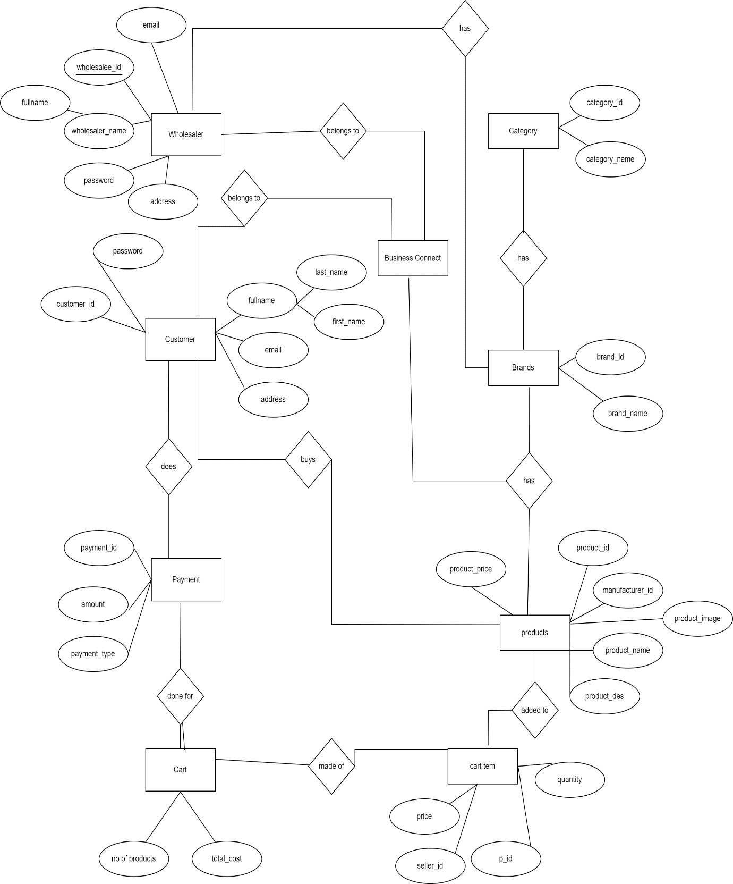

Figure 2: Entity Relationship Diagram

## **2.2 Analysis of Possible Solution**

### **2.2.1 Requirement Analysis**

Identification and evaluation of the requirements for the proposed system are the primary goals of requirement analysis. Understanding the system's user requirements, system requirements, functional requirements, and non-functional requirements is helpful.

#### **2.2.1.1 Functional Requirement**

Functional requirements are the elements which are essential for the website to function properly. In case of business connect some of the functional requirements are listed below:

For Retailer:

* Login
* Upload or edit product with information (Price, description, Image)
* Notification when order is received.
* View list of orders and customer details.

For Wholesaler:

* Login
* Can navigate and create shopping carts as guests.
* Notification for order confirmation.

For Admin:

* Login
* Approve various suppliers on the website
* View supplier on website (Add or remove)

#### **2.2.1.2 Non-Functional Requirement**

The non-functional requirement are the system attributes which serve as constraints or restriction on the design of the system across the different backlogs.

**Platform**

This requirement is related to the hardware and software which is related to our project system. As our project is web based, the important software requirement is a browser which runs into a hardware platform which can be either windows, mac, or android OS. As the requirements are launched into different environment, it establishes how well the website performs in cross platform.  So, we have decided to make a website which can be suitable for all the OS.

**Communication**

This requirement is related for the communication which is required within the system to interact with other system. Sending and receiving the order, authentication while logging into the profile, setting up the payment after placing the order are some of the communications which can happen within the system.

**Performance**

This requirement defines how fast the website, and its responses are with the increase of workflow. Performance is generally perceived as time expectation, so choosing the right technology is very crucial at this point. Considering the modern PC with latest version of browser will be one of the requirements whereas while developing the website using the modern programming language like python, java and Ruby would be a plus point.

**Security and Privacy**

This requirement is to motivate the secure system pattern. The components which can be in our projects are secure communication channels, encrypting messages and data with access controls like password checks on user identity.

**Economic**

The budget has not been allocated since this is a university assignment project however, if the website is launched the cost of running the website will be around the estimates stated in table below:

Table 2: Cost estimate for website additional functionality in 2022

|  |  |
| --- | --- |
| **Website Feature** | **Upfront Website Cost** |
| Website Domain | $12 - $60 |
| Website Hosting | $35 - $600 |
| SSL Certificate | $0 - $200 |
| Website Template or Theme | $0 - $200 |
| Ecommerce Functionality | $20 - $24,000 |
| Website Content | $0 - $5,000 |
| Apps and Integrations | $0 - $100 |
| SEO and Marketing | $0 - $90 |

### **2.2.2 Software and System Architecture**

#### **2.2.2.1 Architecture Objective**

Our website's name is Business Connect, and it will provide a unique way for wholesalers and retailers to connect. There will be registered users, administrators, wholesalers, and retailers on this website. The website's major goal is to link distributors and shop owners in an innovative approach to reach a larger market. The platform will assist distributors in providing a variety of bargains from which retailers may choose the best deals for their business.

#### **2.2.2.2 Three-Tier Architecture**

The website for Business Connect is built using a three-tier architecture module. The reason is due to its advantages such as that it can be developed faster, it improves the scalability, and it provides high security to the database. The data tier that will store back-end data (like user information, admin information, event details, emergency services details etc.) The logic underlying the application (programming language such as PHP and business logic that supports the application's fundamental functions) will be in the application tier, while the presentation tier will be a Graphical User Interface (GUI) that communicates with the end users.

* **Presentation tier:**

The presentation tier is the application's user interface and communication layer, which is where the end user interacts with it. Its primary function is to present information to and gather data from the user. This tier can be accessed by a web browser, a desktop programme, or a graphical user interface. We will be using HTML/CSS and PHP for web presentation tiers.

* **Application tier:**

The heart of the system is the application tier, often known as the logic tier or middle tier. Information from the presentation layer is handled at this tier, sometimes in conjunction with data from the data tier, using business logic, or a set of business rules. The data tier can also be added to, deleted from, or modified by the application tier.

* **Data tier:**

The data tier, also known as the database tier, is where the application's data is kept and maintained. It can be a relational database management system MySQL. The primary advantage of three-tier architecture is the logical and physical separation of functions. Each tier can run on the operating system and server platform that best suits its functional requirements, such as a web server, application server, or database server.

Figure 3: Three-tier architecture

**

Figure 4: Class diagram

### **2.2.4 Activity Diagram**

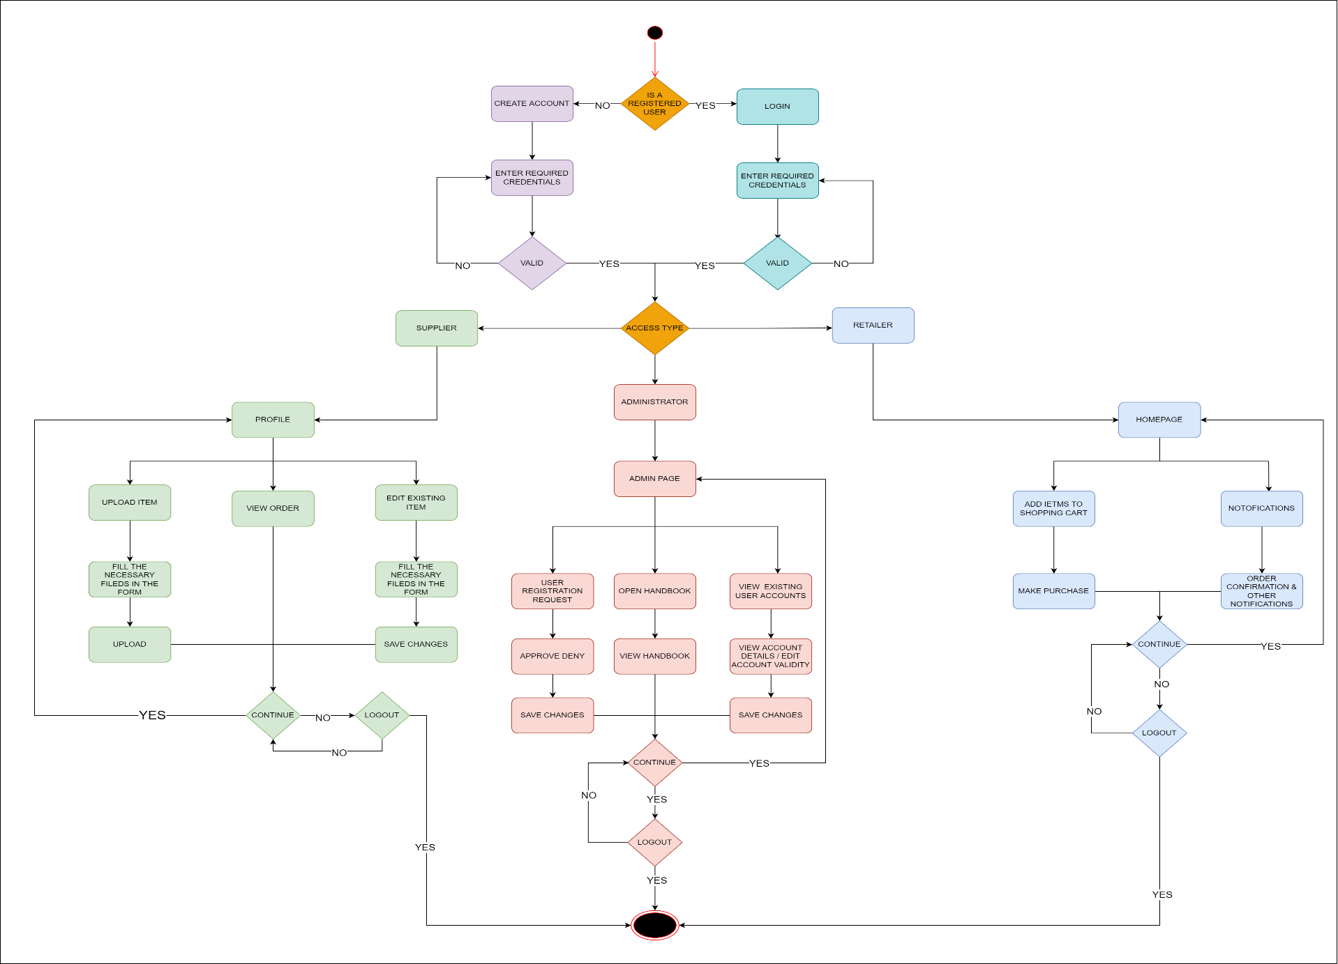

Figure 5: Activity diagram

### **2.5 Sequence Diagram**

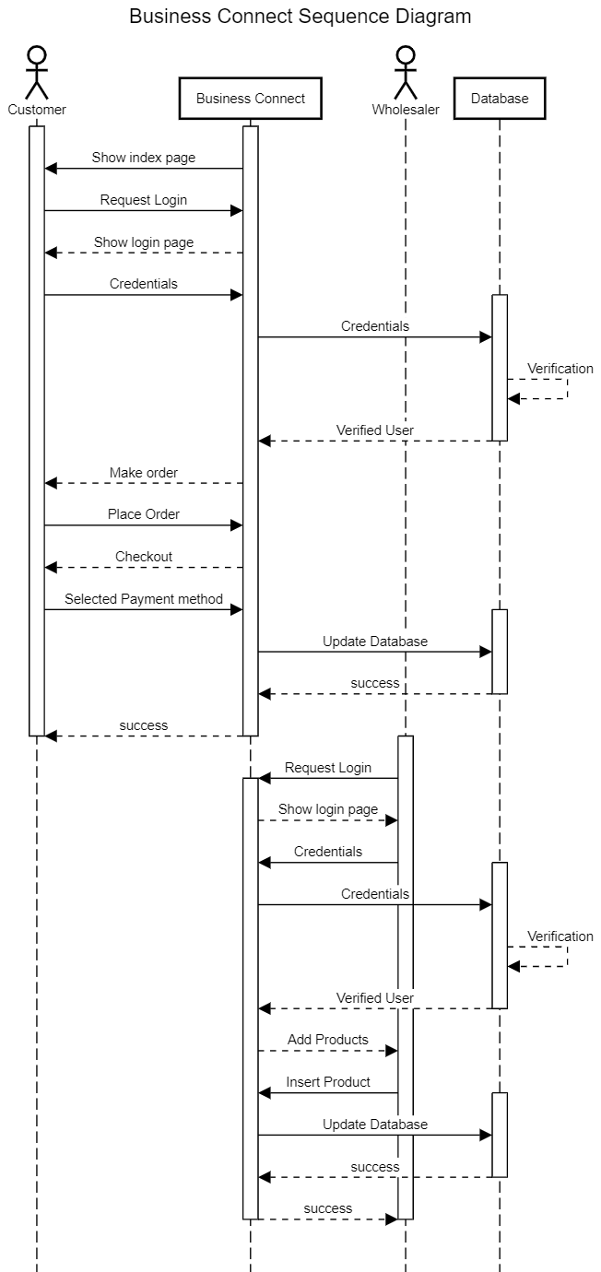

Figure 6: Sequence diagram

### **2.6 Use Case Diagram**

Figure 7: Use Case Diagram

### **2.7 Test Cases**

Large amount of testing was done throughout the development of the website. Each webpage of the website has gone through extensive testing and have been document separately in excel files. Due to the large size of test case, I have only presented the test cases for the form validation of the website. Other test cases can be provided on request. Below is the screenshot of all the test cases conducted.

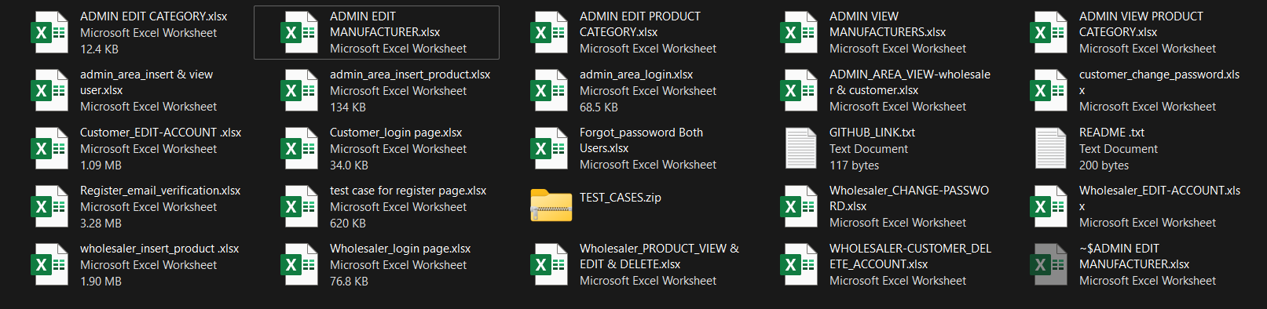

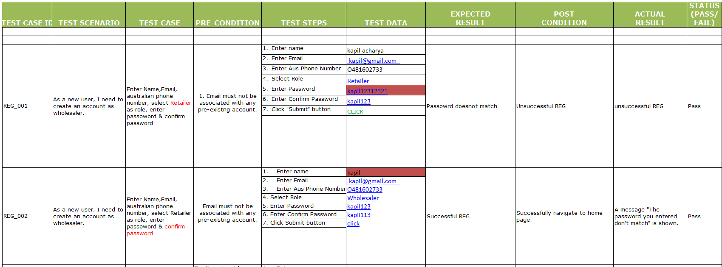

Figure 8: Test cases

# **CHAPTER III: DISCUSSIONS & CONCLUSIONS**

## **3.1 Discussions**

The project was finished on schedule with minor ups & downs and in accordance with the goals. Successful implementation of project can deliver value to wholesalers and retailers in Nepal. Since Agile methodology was used many features were added later into the website. Dividing the project into sprints also helped reduce workload and helped me focus on the objectives and deliverables of the project.

## **3.2 Conclusions**

This was a fantastic learning opportunity for me. My eagerness & curiosity pushed me to add features & features to the website. I did my best to finish this job in stages while keeping it straightforward, efficient, and basic. My key takeaway from this project is to used sprint for larger projects & always try to add new features to existing software.

# **REFERENCES**

* Martin, R. C. (2009). *Clean Code*. Prentice Hall.
* Jakobus, B., & Marah, J. (2018). *Mastering Bootstrap 4 - Second Edition: Master the latest version of Bootstrap 4 to build highly customized responsive web apps* (2nd Revised edition). Packt Publishing.
* *GitHub: Where the world builds software*. (n.d.-c). GitHub. <https://github.com/>
* *PHP: Hypertext Preprocessor*. (n.d.). PHP: Hypertext Preprocessor. <https://www.php.net/>
* *MySQL Tutorial*. (n.d.). Tutorialspoint. <https://www.tutorialspoint.com/mysql/index.html>

# 

# **APPENDIX**

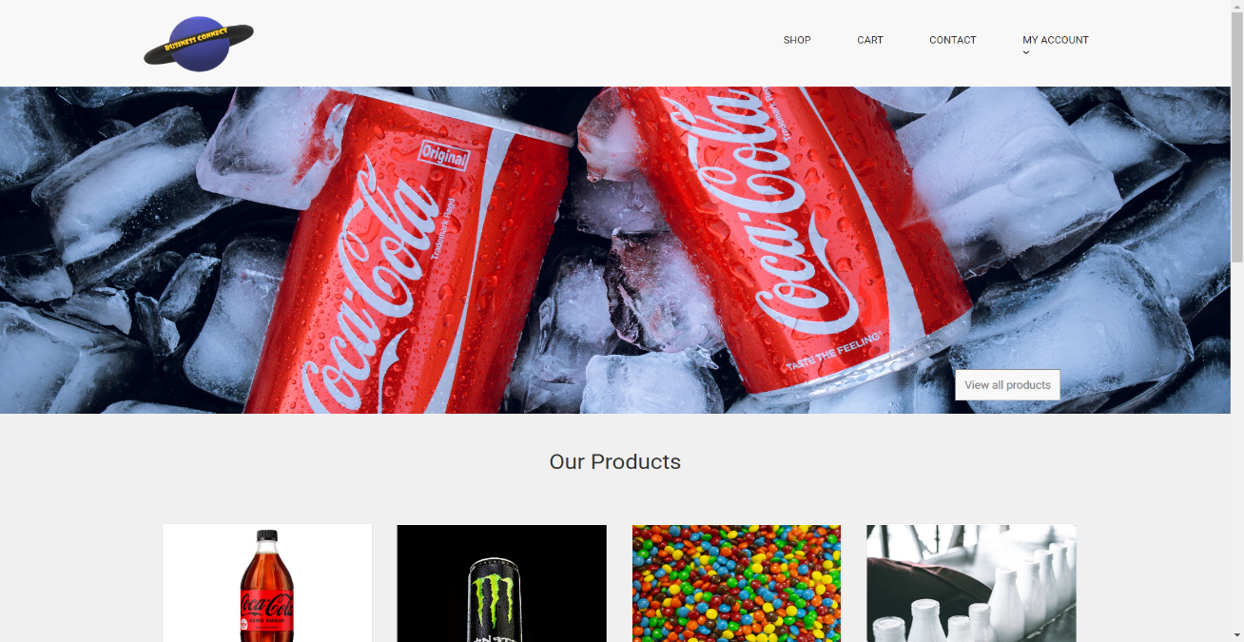

Figure 9: Index page

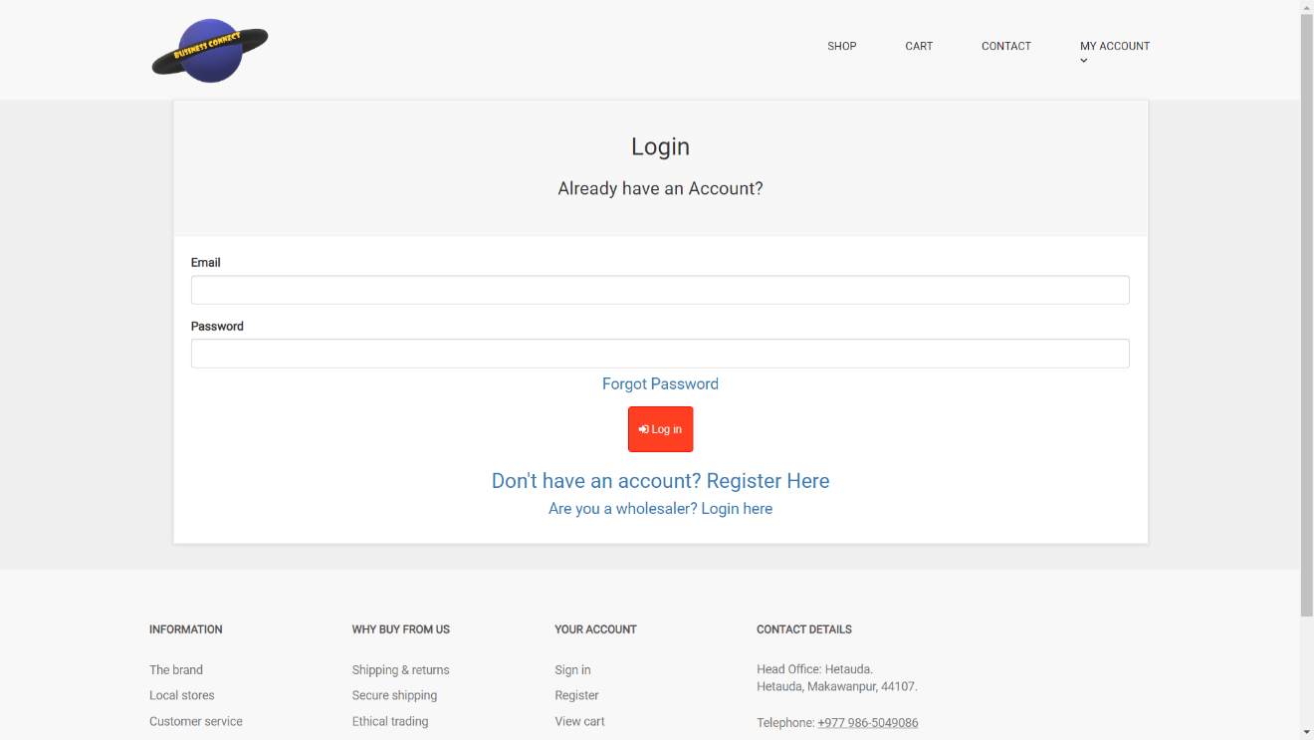

Figure 10: Retailer login portal

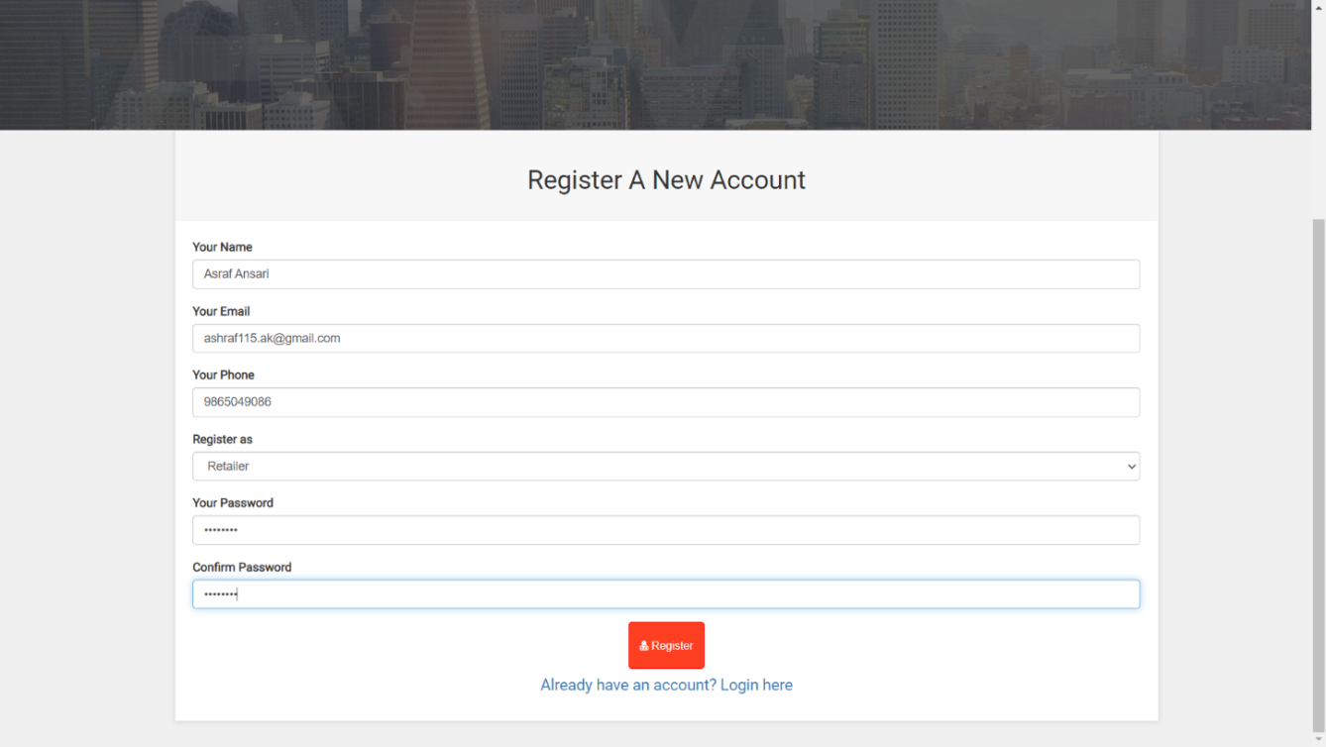

Figure 11: Retailer registration page

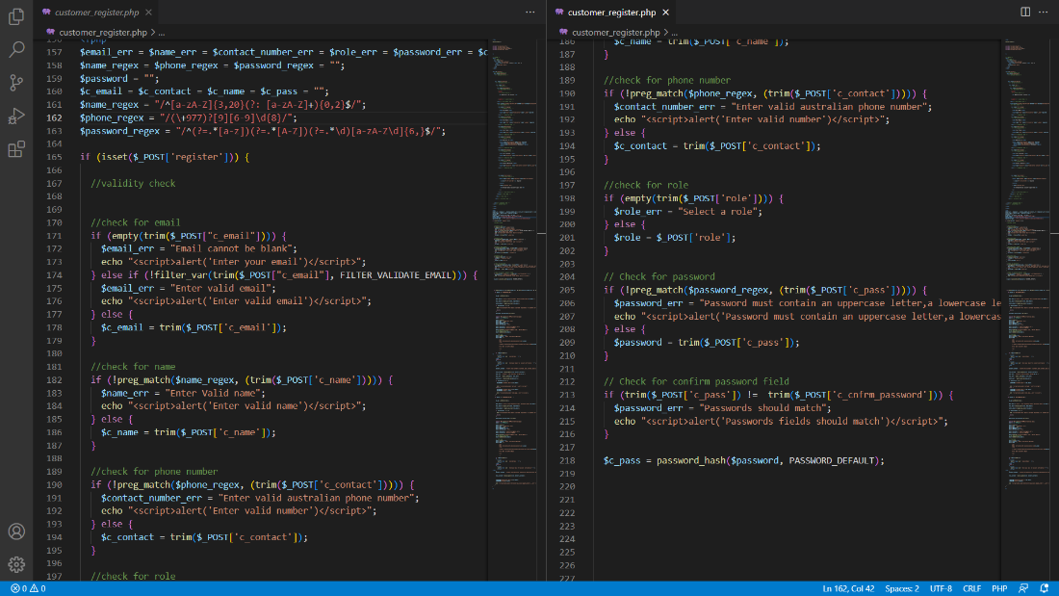

Figure 12: Registration form validation

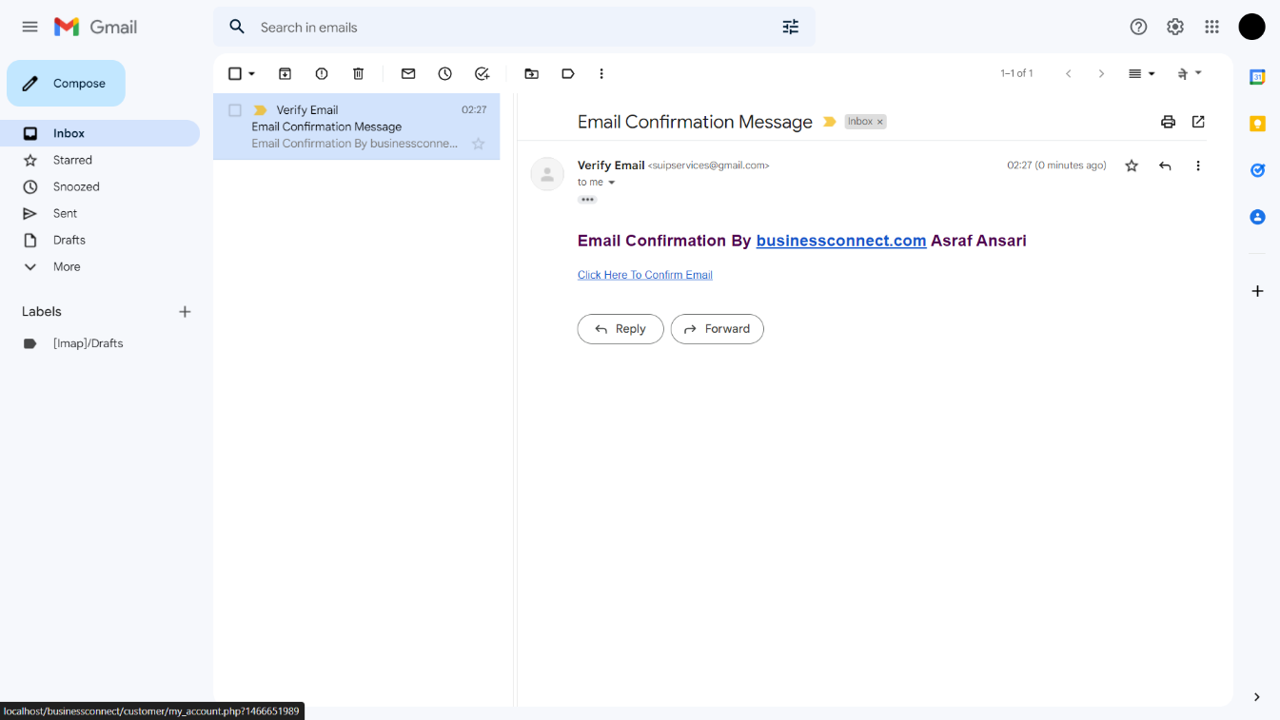

Figure 13: Registration Mail Verification

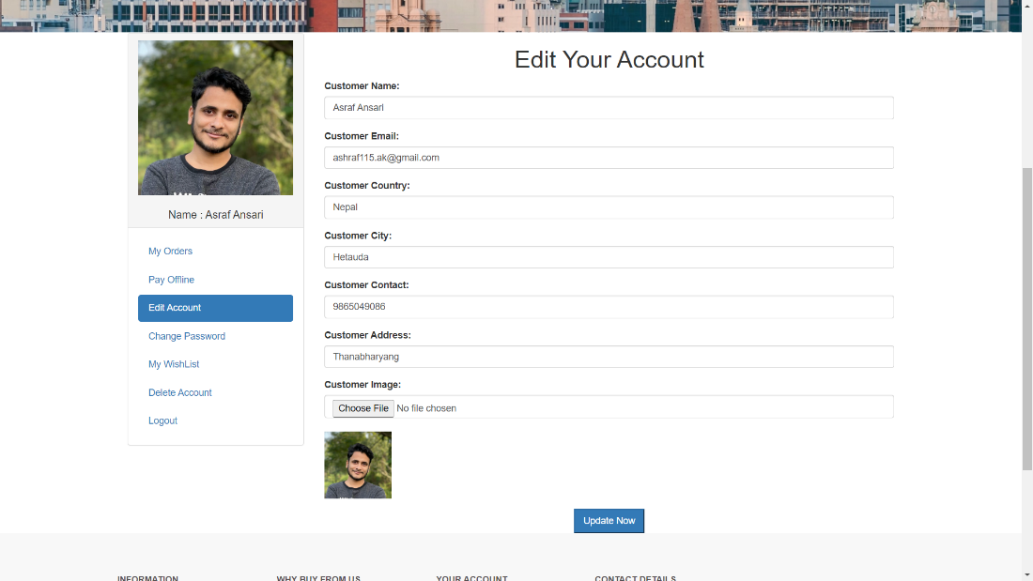

Figure 14: Edit User Account

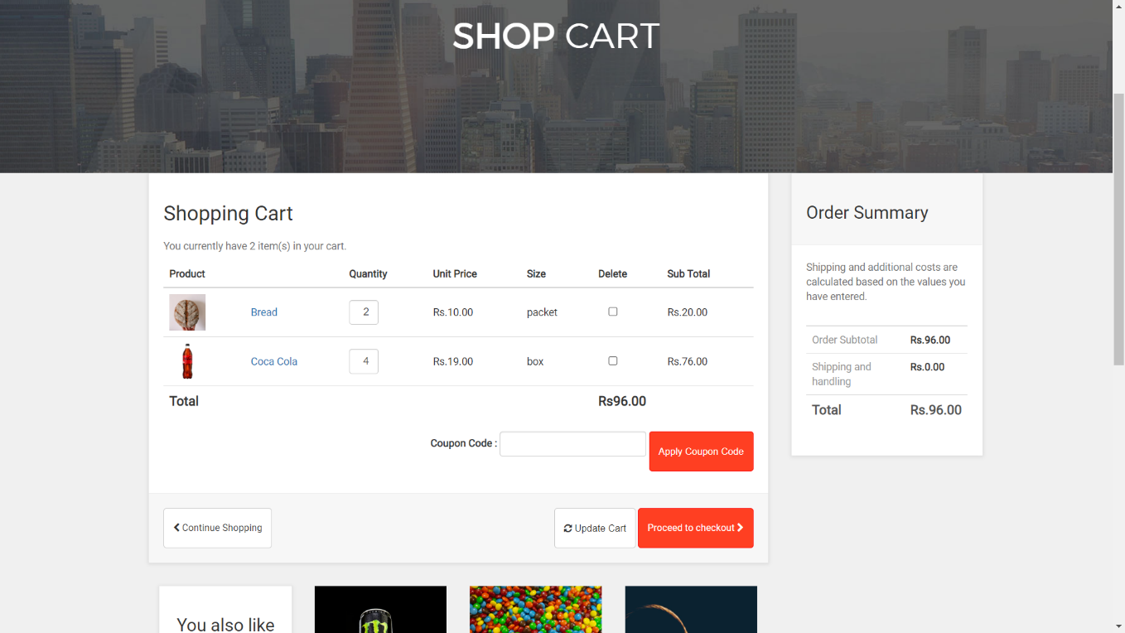

Figure 15: Cart

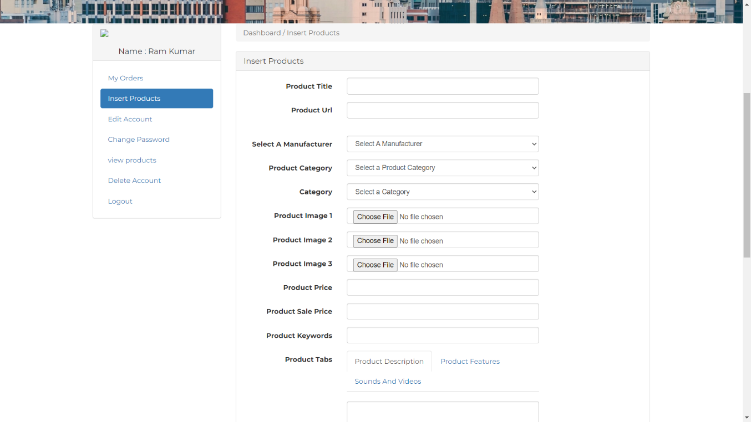

Figure 16: Add product by wholesaler

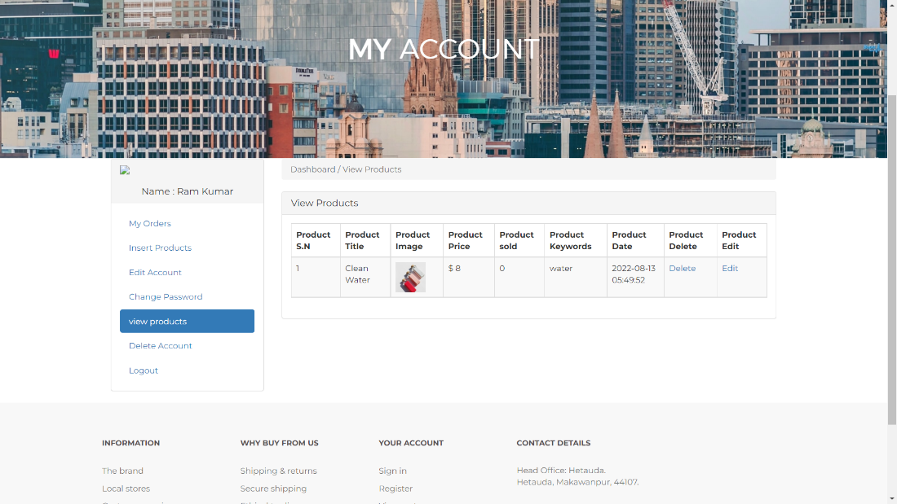

Figure 17: View own products added by wholesaler

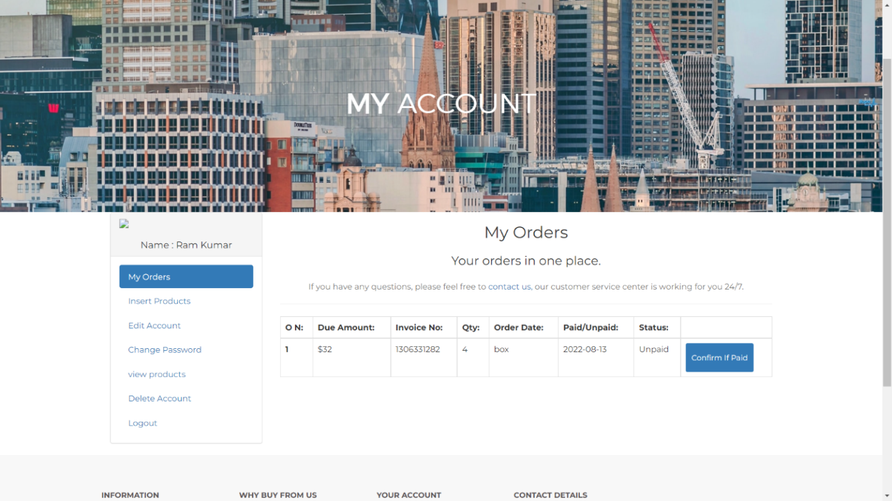

Figure 18: Order made by customer

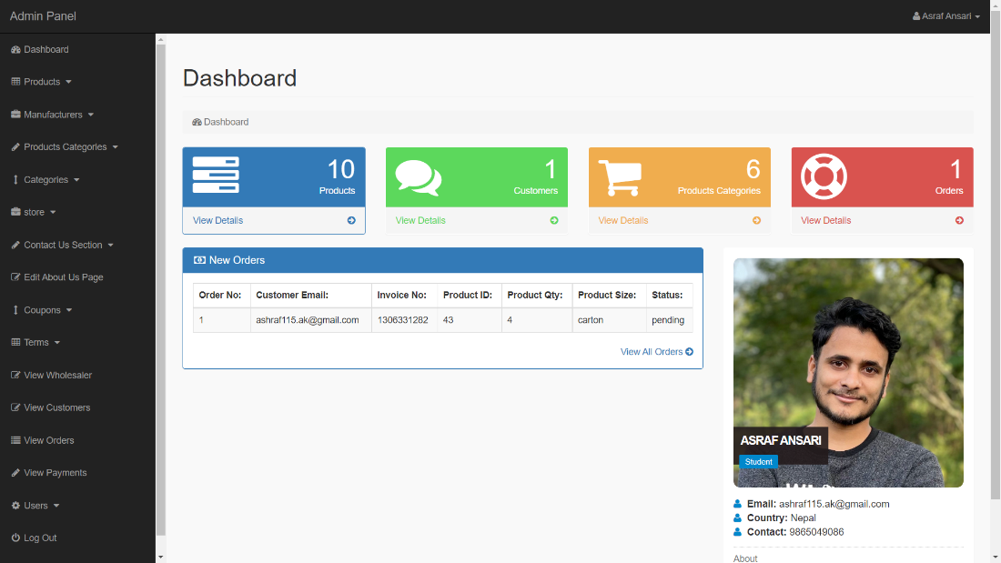

Figure 19: Admin dashboard

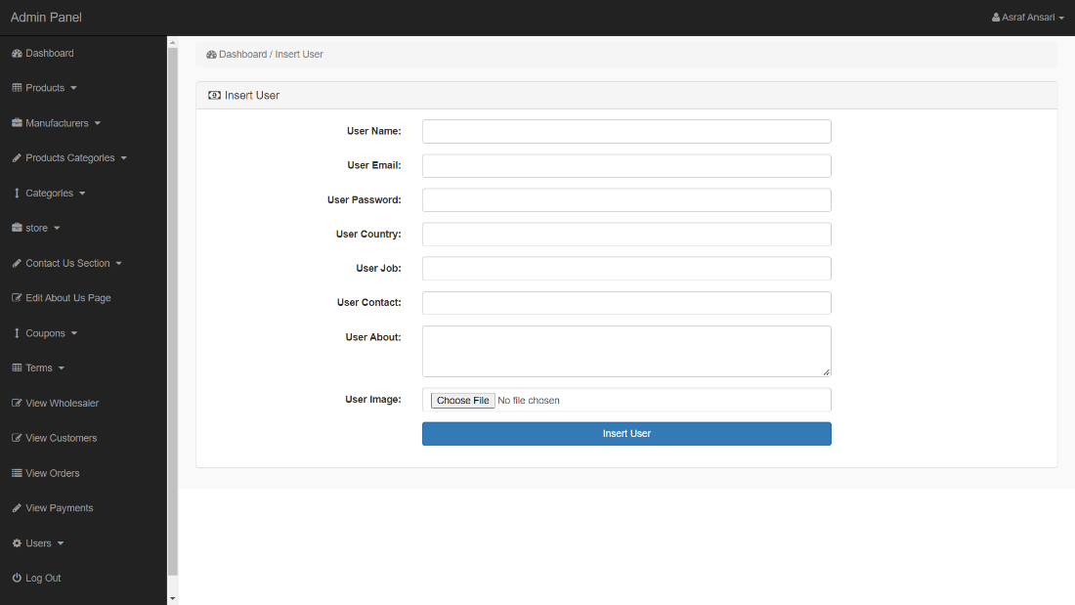

Figure 20: Admin insert user

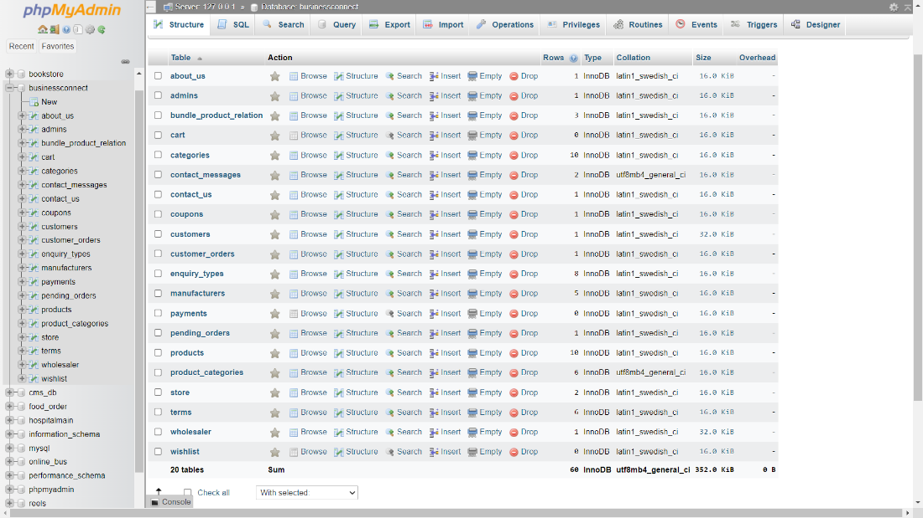

Figure 21: Database overview